**URL Shortener Web Application (Basic)**

**Project Workflow**

1. After logging in, the main web-application opens which is the URL shortener. Here the user can enter the URL he wants to shorten. After entering a URL, click on the ‘shorten’ URL button to display the shortened URL in the following text-field which can be copied by clicking on the copy button.
2. After the ‘shorten’ button is clicked, the URL that is entered is saved in our database with the shortened URL. It is saved in the database so that the user can look into the previous URLs he entered in our web-app with their shortened URL in the forms given below the copy button.

3. Try to verify the URL entered by the user is correct or not. (Do some googling to find out how to make it possible)

Step-1

Install Necessary Packages

pip install flask

pip install flask-sqlalchemy

pip install flask-migrate

pip install validators

Step-2

Import the Necessary Packages

import os

from flask import Flask, render_template, request, redirect, url_for

from flask_sqlalchemy import SQLAlchemy

from flask_migrate import Migrate

from flask_login import LoginManager, UserMixin, login_required, login_user, logout_user

import string

import random

import validators

Step-3

Configure the SQL Alchemy

Next Create two Tables in Database

Urls- for storing Original url, full url and short url

Original and full url -string with size upto 500

Short url – string with size upto 10

Step-4

Create tables

@app.before_first_request

def create_tables():

    db.create_all()

Step-5

Take url from the user and validate using validators function

Pass url to shorten_url() function

def shorten_url():

    chars = string.ascii_letters + string.digits

    while True:

        short_url = ''.join(random.choice(chars) for _ in range(6))

        full_url = request.host_url + short_url

        if not Url.query.filter_by(short_url=short_url).first():

            return short_url,full_url

1. The **shorten_url** function takes the original URL as input and returns the shortened URL.
2. Generating a Unique String: The **chars** variable contains a string of all uppercase letters, lowercase letters, and digits. Using this, we can generate a unique string of 6 characters using the **random.choice** function.
3. Encoding the URL: The original URL is encoded using base64 encoding, which produces a string of characters that can be easily stored and retrieved from the database.
4. Saving to the Database: The original URL and the shortened URL can be saved to a database using an ORM or other database technology.
5. Returning the Shortened URL: The function returns the shortened URL, which includes the unique string and the domain name.

@app.route('/<short_url>')

def redirect_to_original_url(short_url):

    url = Url.query.filter_by(short_url=short_url).first()

    return redirect(url.original_url)

Step-**6**

Html Pages

1. Home Page: The home page contains a form that allows the user to enter the original URL.
2. History Page: The history page displays a table of all the previously shortened URLs.
3. Index Page: Shows the Description of the Page
4. Layout Page: Consists of all CSS styles, Nav bar for all Pages
5. Login Page: Authentication in order to Shorten Link
6. Register Page: For Creating a user account
7. Result Page: Give Shorten URL to User for Original URL and Copy Button to Copy the Shorten Link

Step-9

Migrate the database to the app

Run these commands to initialize the Database

flask db init

flask db migrate -m “—Message--”

flask db upgrade

Step-10

Run the Python code app

python app.py

Step-11

Home

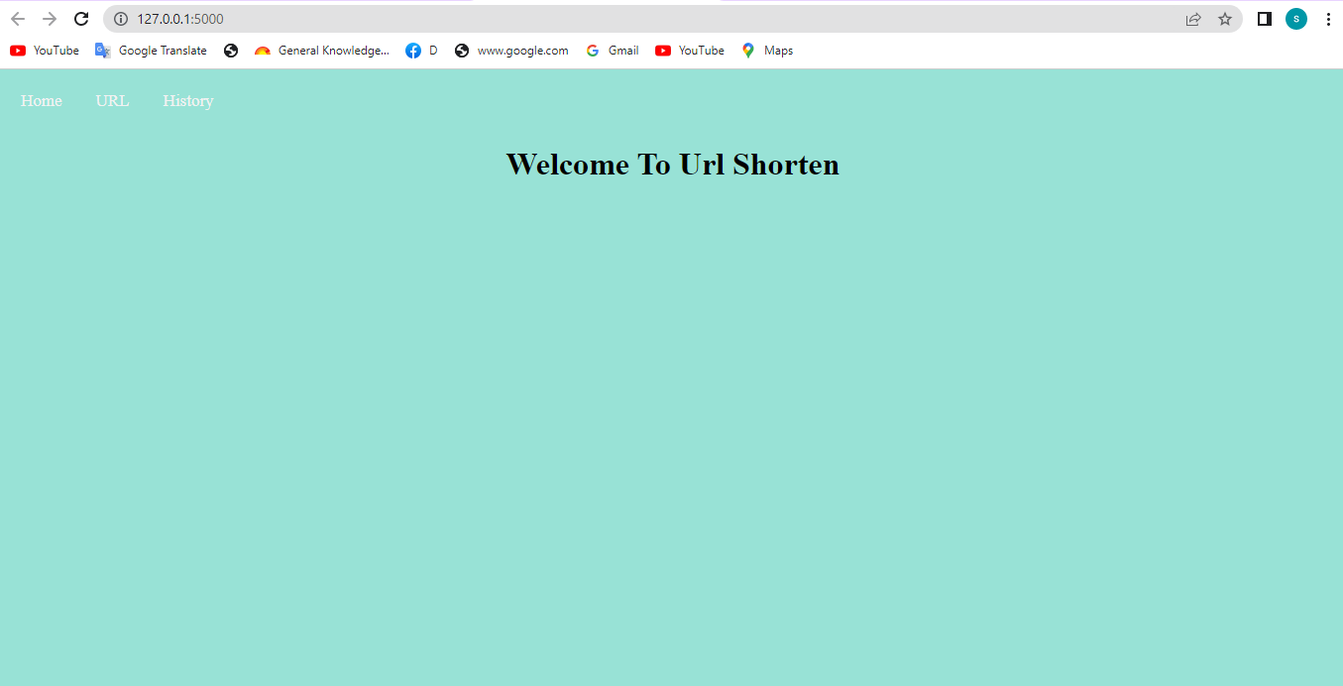

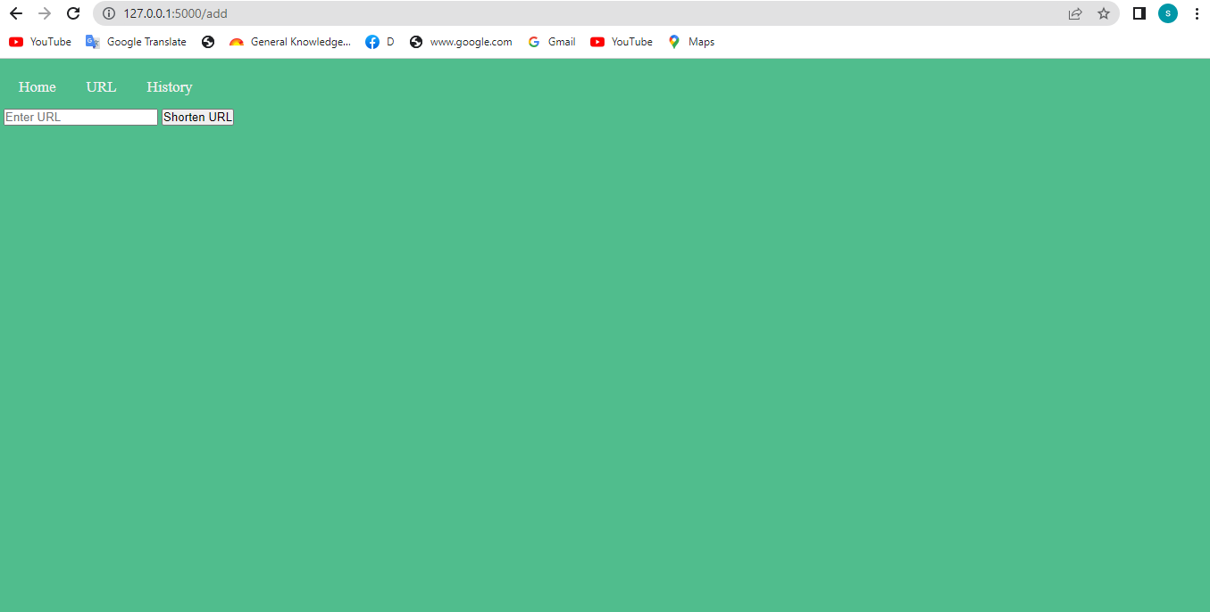

Shorten Url

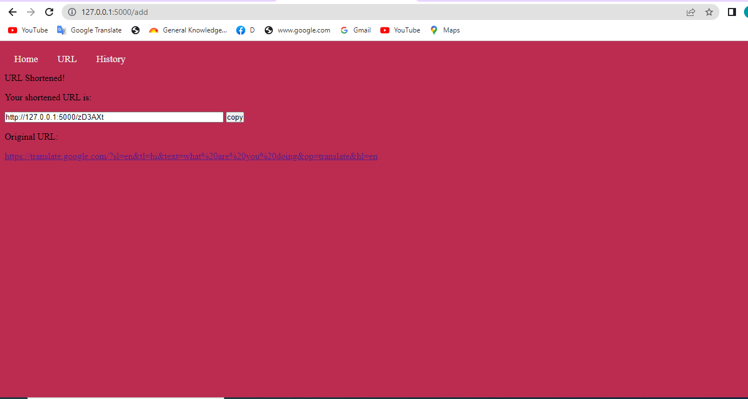

History

